THEORY QUESTIONS
1.
(a)

Simplify the expression 3x² + 6xy – 3y² + 4x² + 8xy + 2y²
(b)

(i)

Solve 3x – 9 ≥ 12 (x – 3)
(ii)

Illustrate your answer on the number line.
(c)

If p = 7, a = 16, b = 4 and c = 3, evaluate p² -
(a - b)
c

2.
(a)

Using a ruler and a pair of compasses only,
(i)

construct a triangle PQR such that |PQ| = 8 cm, angle RPQ = 90° and angle PQR = 30°. Measure |RQ|
(ii)

construct the perpendicular bisector (mediator) of RQ. Let it meet RQ at O.
(b)

With O as centre and radius OP, draw a circle. Measure |OP|.
(c)

What is the special name for the chord RQ?

3.
(a)

A man travelled from Bakwa to Pabam. The distance between the two towns is 510 km. At Pabam he covered additional 40 km on official duties. He returned to Bakwa the next day.
(i)

Find the total distance covered by the man
(ii)

If the car used one litre of petrol to cover 20 km, find the amount of petrol used for the whole journey.
(iii)

If a litre of petrol cost ₵522.00, calculate the total cost of petrol used for the whole journey.
(b)

A woman sold an article for ₵200,000.00. She made a profit of 25%. Find the cost price of the article

4.
(a)

The pie chart shows angles representing the number of candidates who applied for admission into four programmes at a senior secondary school. The number of pupils who applied were 1080.
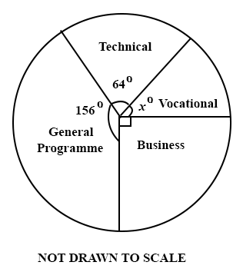
Find:
(i)

the angle x° representing the Vocational programme.
(ii)

the number of candidates who applied for Business programme.
(iii)

correct to the nearest whole number the percentage of the number of applicants who applied for General Programme.
(b)

The data below shows the distribution of the masses of pupils in a school. On a graph paper, draw a bar chart for the distribution.
Mass (kilograms) | 19 | 20 | 21 | 22 | 23 | 24
Frequency | 5 | 9 | 19 | 25 | 18 | 4

5.
(a)

Using a scale of 2 cm to 2 units on both axes, draw two perpendicular axes OX and OY on a graph sheet. On the same graph sheet, mark the x-axis from –8 to 8 and the y-axis from –8 to 8
(i)

Plot P(-2, 3) and Q(6, 4). Join PQ
(ii)

Draw the image P₁Q₁ of PQ under an anticlockwise rotation through 90° about the origin, where P→P₁ and Q→Q₁. Indicate clearly all the co-ordinates.
(iii)

Draw the image P₂Q₂ of PQ under a clockwise rotation through 90° about the origin where P→P₂ and Q→Q₂. Indicate clearly all the co-ordinates
(b)

The base radius of a closed cylinder is 4 m. The height of the cylinder is 7 m. Calculate its total surface area.
[Take π =
22
7
]

